**EFS AND EBS**

# EFS

1. EFS means elastic file share first we have to create vpc,subnet,rout table and internet gate way.
2. Internet gate way attach to the vpc and rout table attach to the subnet.

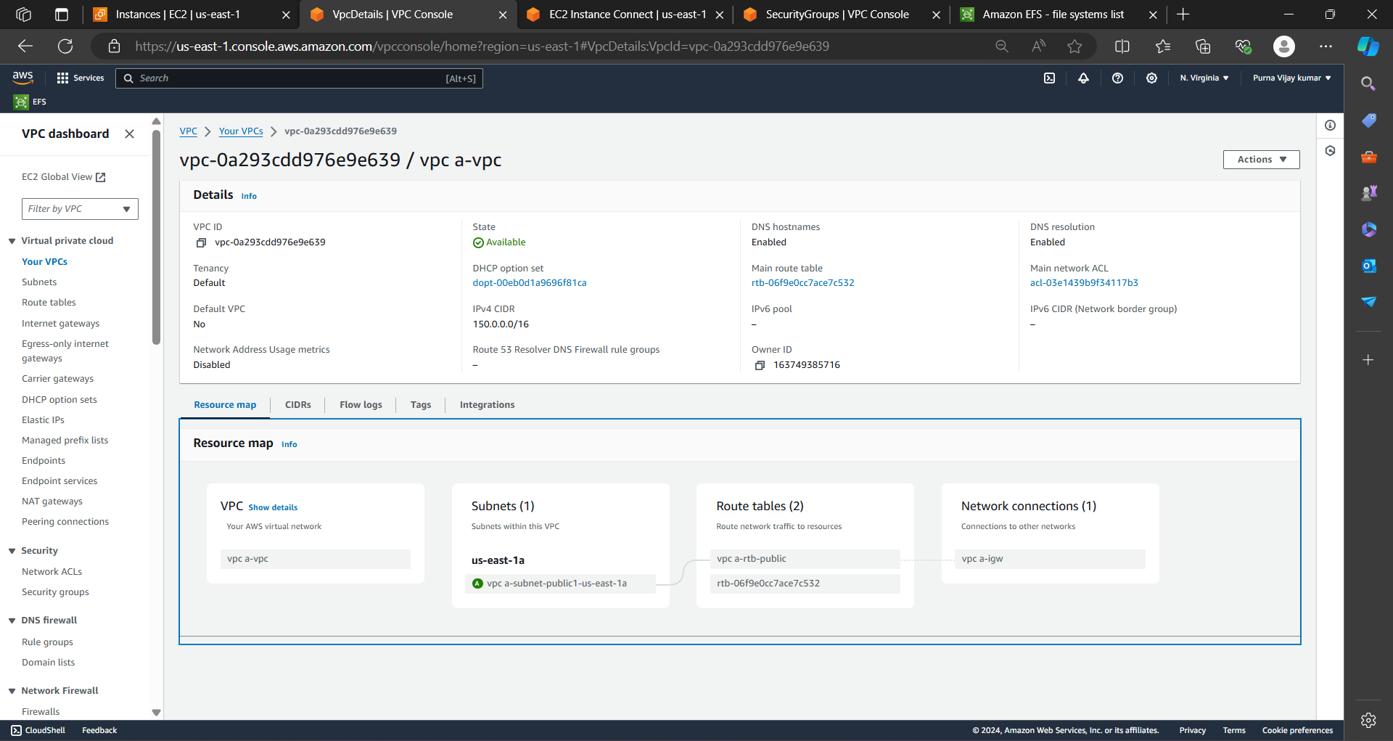

3.Then create security group and attach to the vpc that you have created.

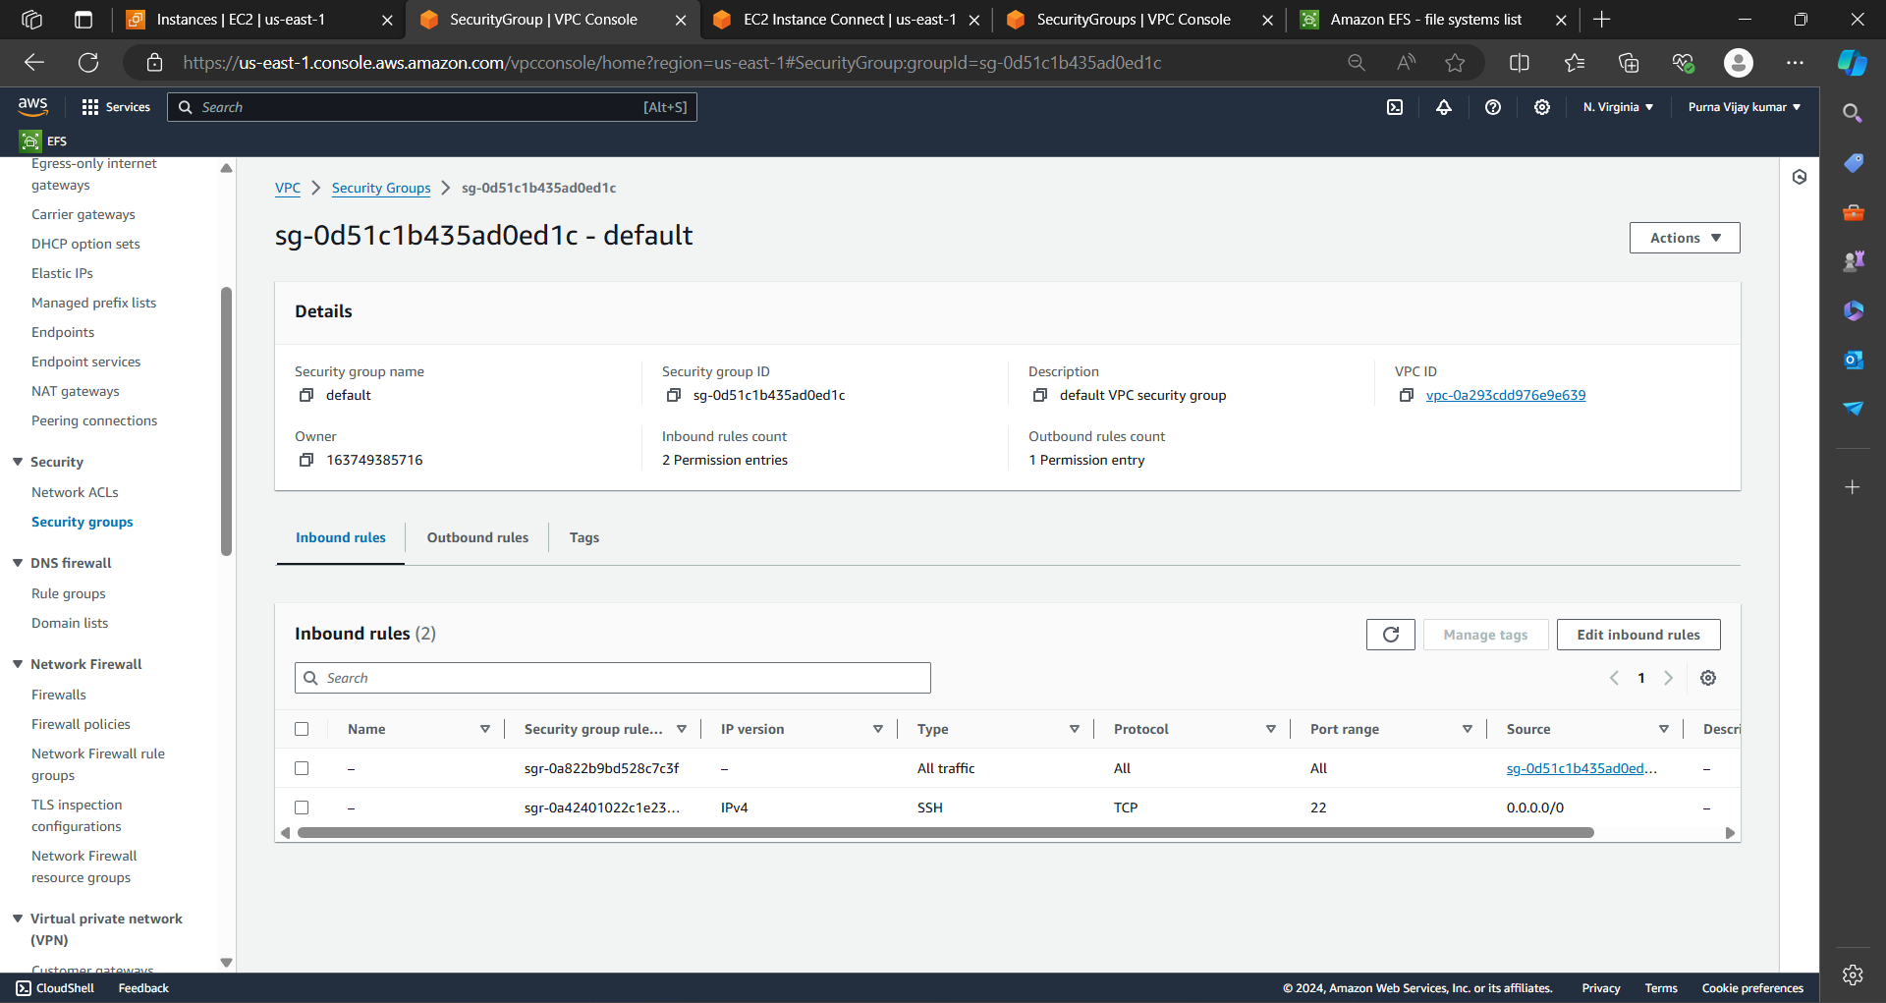

4.Then create EFS and customize the efs and add securite group to efs.

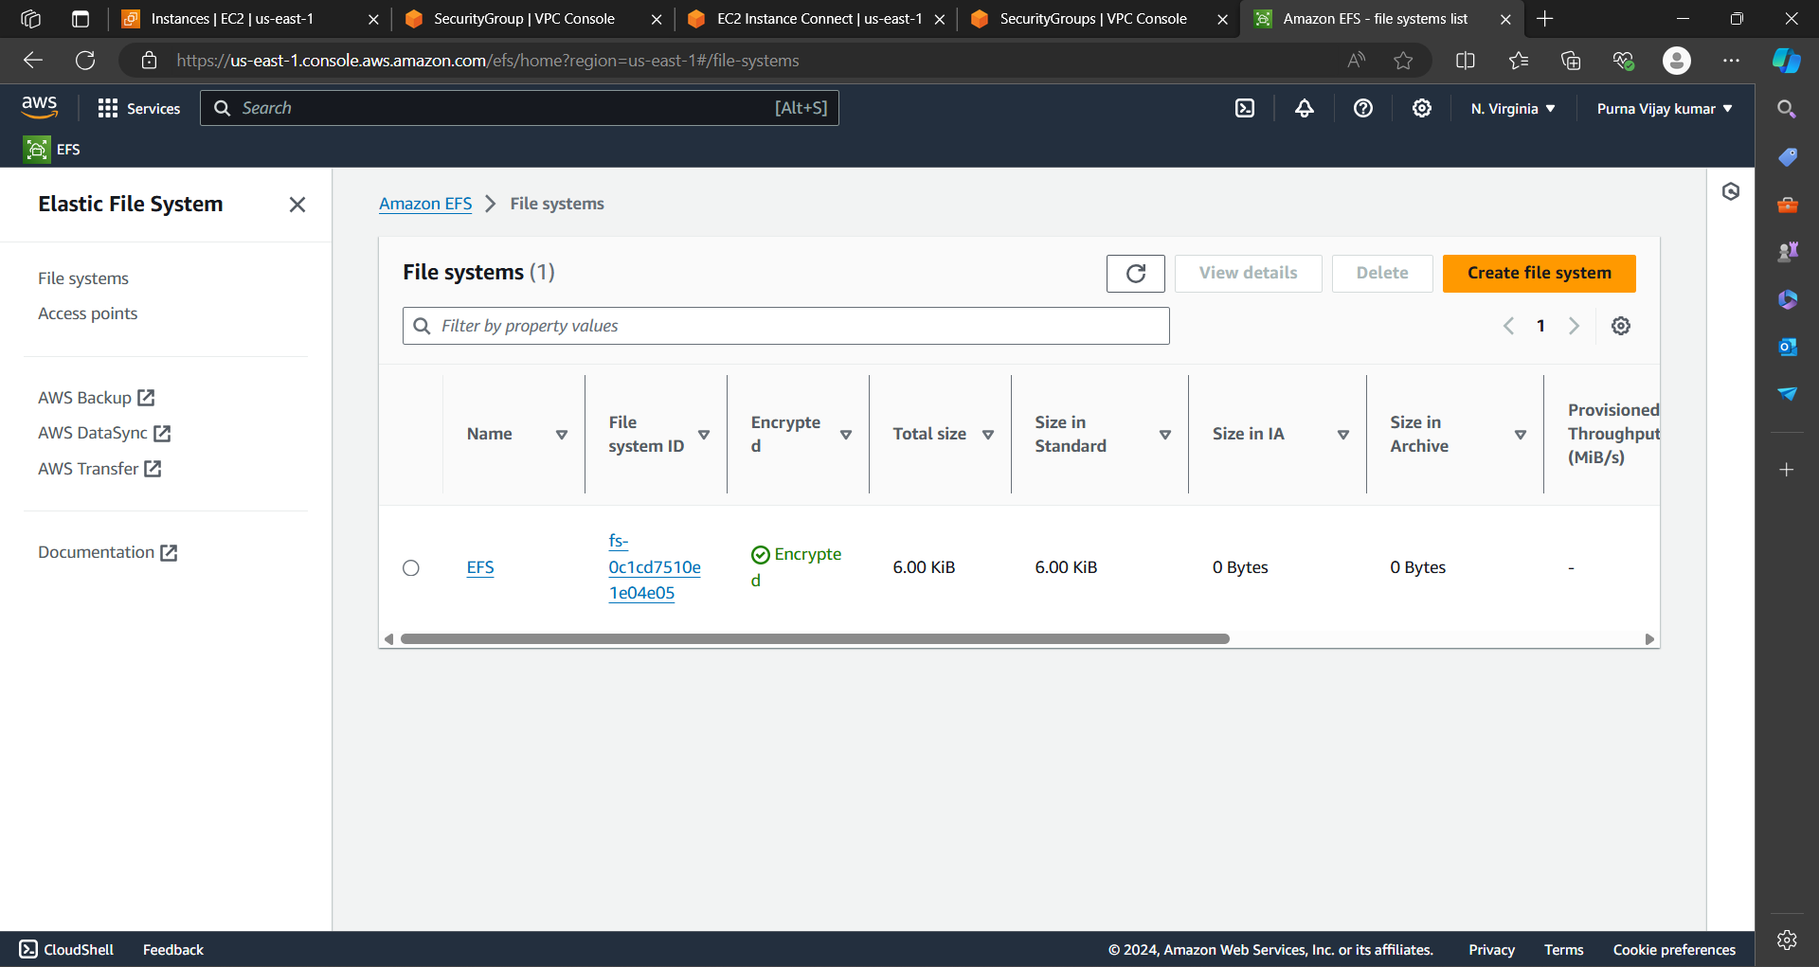

5.After that launch two instance that are in same avalibality zone and same region.

6.Give security group which we have created and add elastic file to the two instances

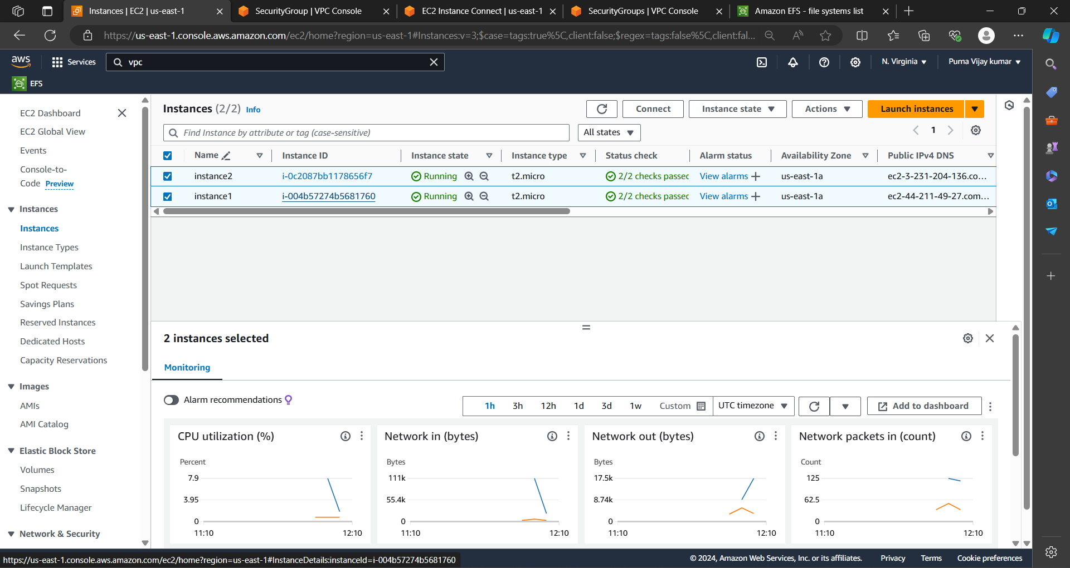

7.Then open git bash run the first instance and change the mount point as cd /mnt/efs/fs1 and create any file or directory.

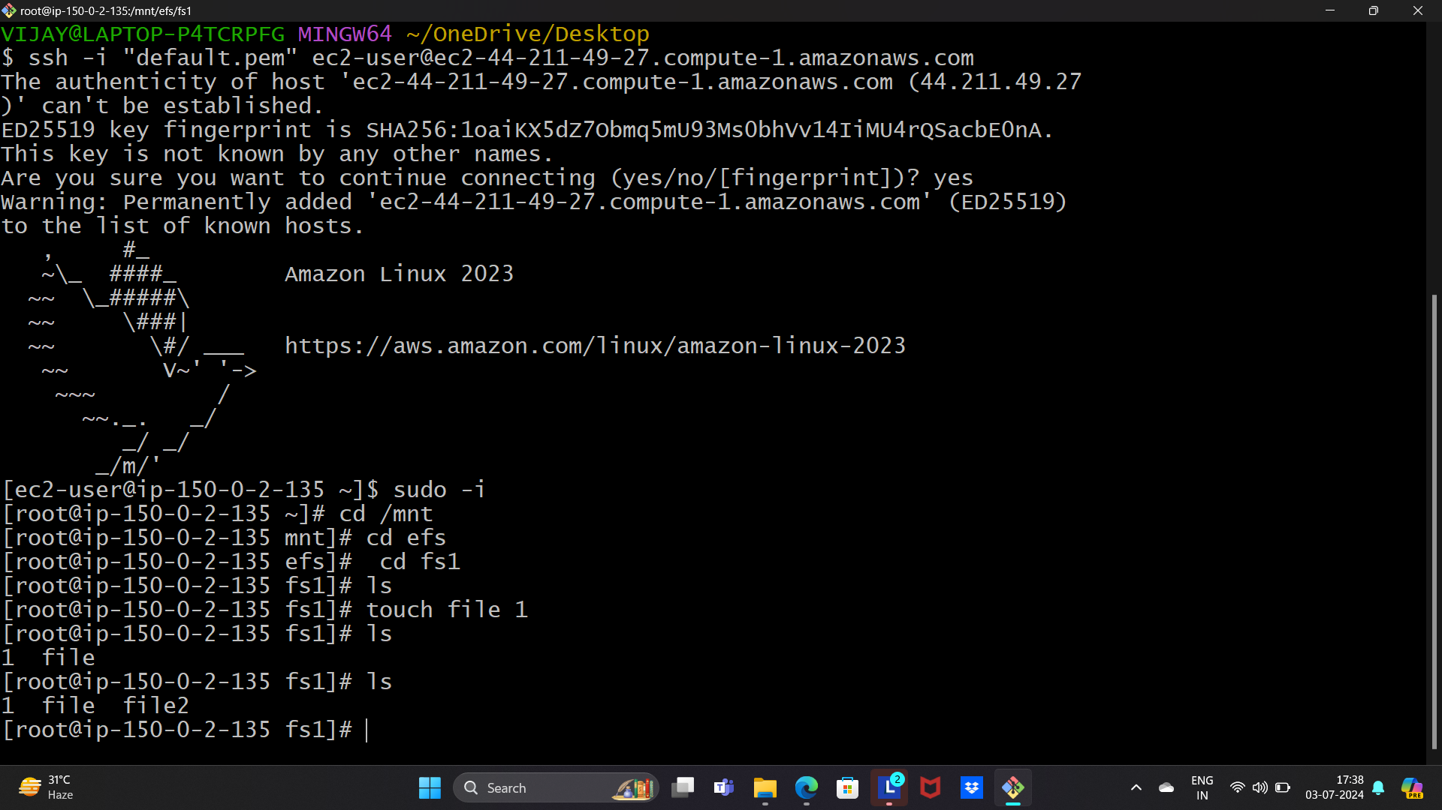

8.Run the second instance and change the mount cd /mnt/efs/fs1 and create any file or directory.

9.Then you can see that files are sharing from one instance to another as shown in above and below figures.

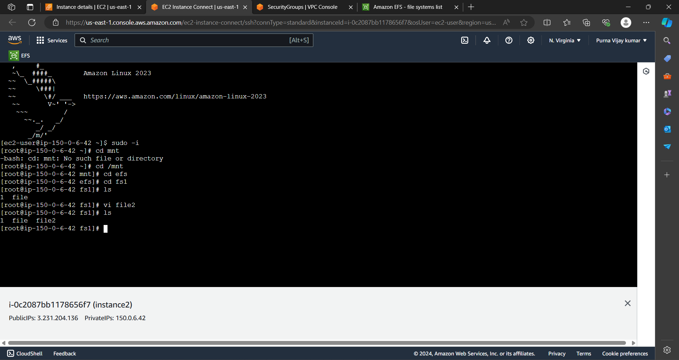

# EBS

1.EBS means elastic block storage it is an external storage for any instance we can connect.

2.launch instance as shown in the below fig.

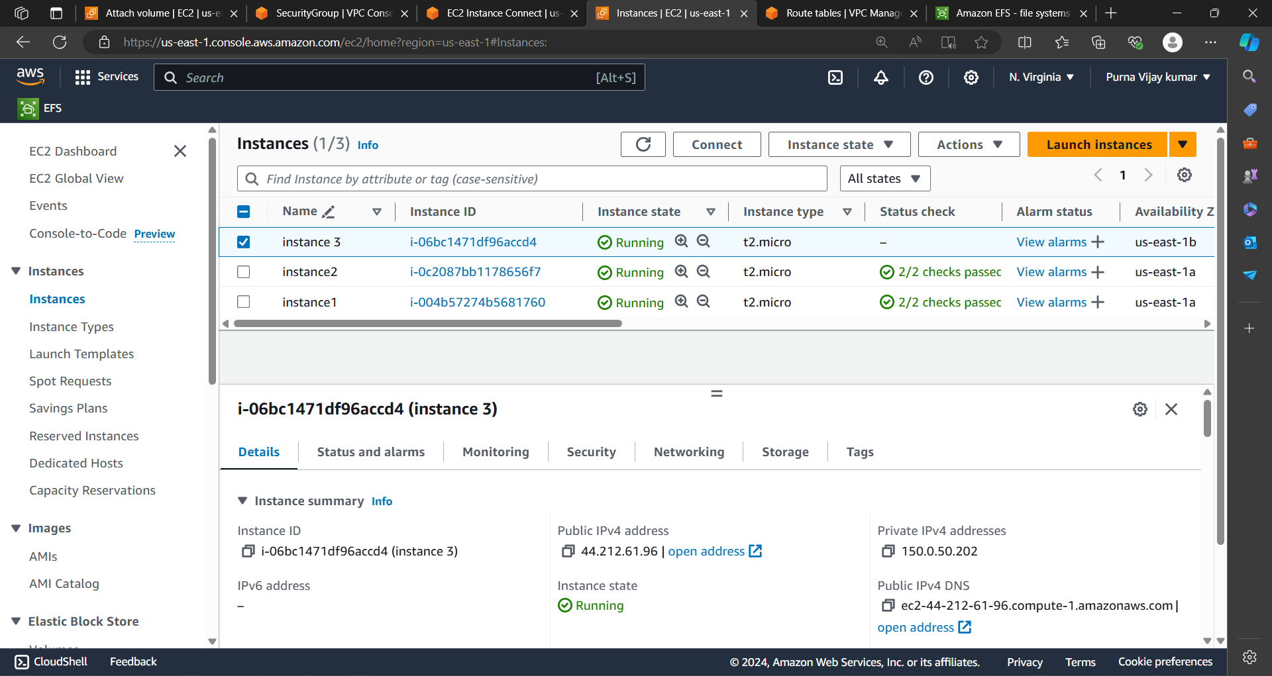

3.create volume for the instance with the same avalibility zone where as instance lunched.

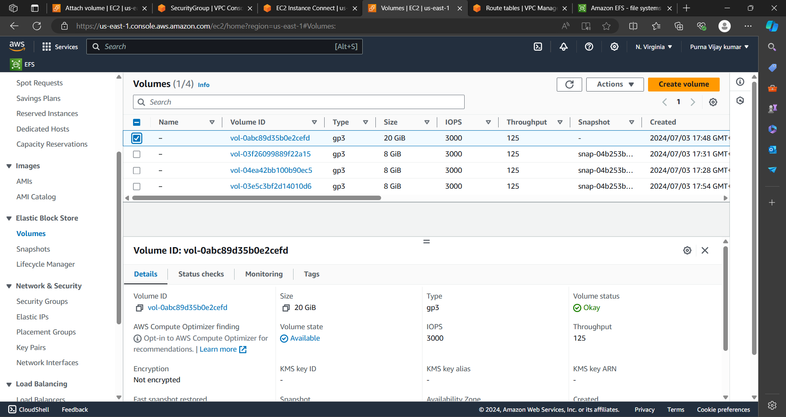

4.Attach volume to the instance where as we created

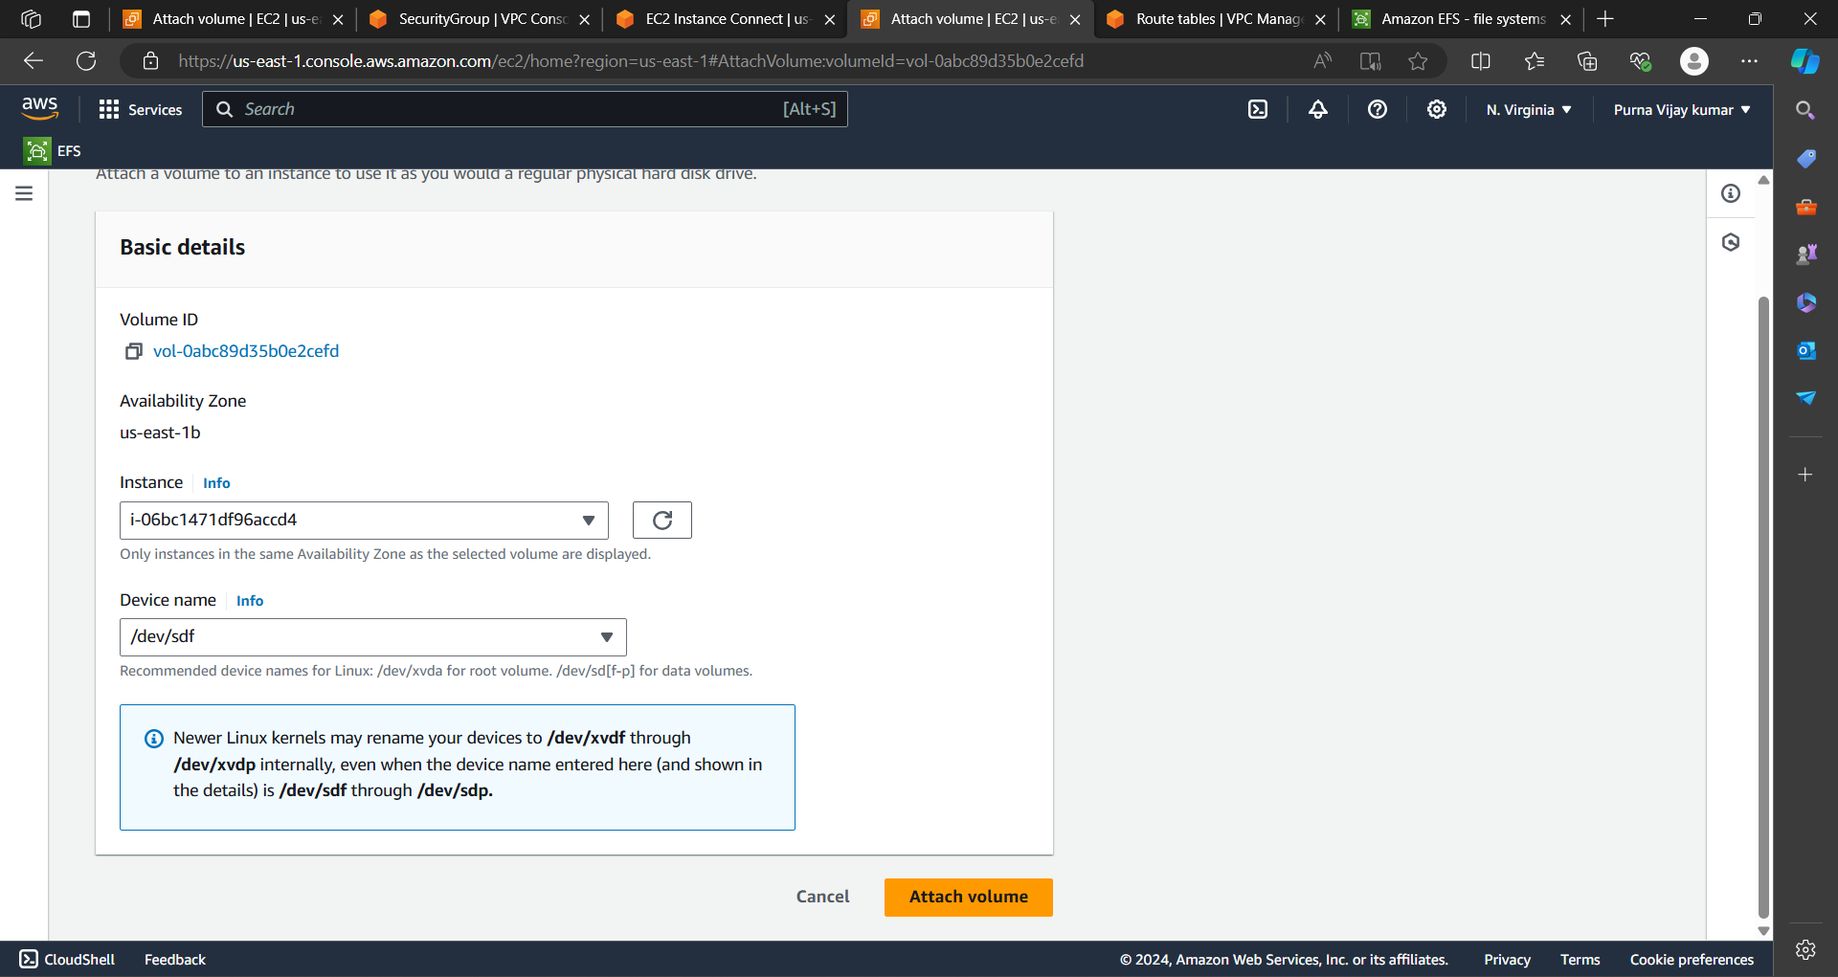

5.Run the instance in the git bash and see the disk of the instance with the ‘df -h’ command and we also modified the volume as shown in the below fig.

